Name: _____________________________________________________________________________ Pd:________
GT Biology: Unit One Test—90 Points
Experimental Design, Scientific Process, Measurement, Chemistry, Macromolecules
- Gibberellic acid (GA) is a hormone that affects the growth of plants. A student predicted that spraying a gibberellic acid solution on corn plants would increase their rate of growth. To test this theory, he planted one corn plant and sprayed the same amount of gibberellic acid solution on it every day for one week. At the end of the week, he found that the corn plant had grown seven centimeters. Based on this observation, he claimed that gibberellic acid had caused the plant to grow faster.
- What is wrong with the student’s claim? Be specific (4 pts).
- How should the student have designed his investigation in order to get useful results? (5 pts)

- Sam claims that water is a molecule. Tom claims that it is a compound. Who is right and why? (2 pts)
- Light travels 3.0 x 10⁸ meters per second. How many kilometers does light travel in a year? (3 pts)
- One molecule of hemoglobin has a mass of approximately 1.09 x 10⁻¹⁰ nanograms. How many hemoglobin molecules are there in one milligram? (3 pts)
- Jenna is preparing growth medium for bacteria and needs to convert microliters to milliliters. The recipe calls for 750 µL of a liquid yeast extract. After converting, Jenna figures that she needs 750,000 mL. You’re a much better lab technician and can tell that she is wrong without doing any calculations. How do you know she’s wrong? (1 pt)
- What do protons and neutrons have in common? (1 pt)
- Potassium has 19 protons. When potassium has a charge of +1, it has (2 pts):
A) 20 protons
B) 19 electrons
C) 18 protons
D) 18 electrons
E) Not enough information to tell
- Which of the following has the most carbon atoms (2 pts)?
A) 25CO
B) 6C₆H₁₂O₆
C)30CO₂
D) 4C₇H₁₆
- What are two differences between hydrogen bonding and ionic bonds (2 pts)?
- Draw two water molecules and clearly indicate the hydrogen bonding between them (4 pts).
- Why is water polar? (2 pts)
- If you have grease on your hands, why does washing them with soap work better than just washing them with water? (3 pts)
- True or false: Water has higher surface tension on glass than on wax paper. (1 pt)
Why? (2 pts)
- Water does not adhere to ________________________________ surfaces (2 pts):
A) Polar
B) Hydrophobic
C) Hydrophilic
D) Glass
- You dump some salt into a glass of water. Answer the following questions:
A) What is the solvent? (1 pt)
B) What is the solute? (1 pt)
C) Explain how the salt dissolves. If a diagram would help you explain, feel free to include one. (3 pts)
- Water has a high specific heat. What does that mean? (2 pts)
- Identify each of the following (2 pts each):
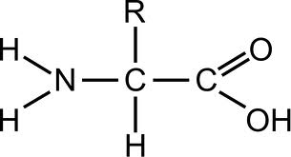 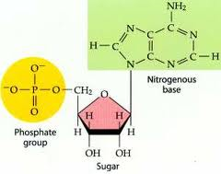
________________________________________ _______________________________________
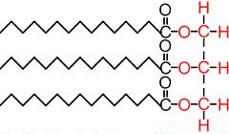 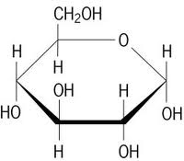
________________________________________ ________________________________________________
- Fill in the following chart (2 pts each):
Macromolecule | Monomer
Protein
 | Monosaccharide
Nucleic Acid
 | Fatty acids/glycerol

Fill in the blanks; be as specific as you can (2 pt each blank).
- _____________________________________ provides structure in the cell walls of plant cells, while cell membranes are made of ________________________________________.
- ________________________ are ______________________________ that speed up chemical reactions in the cell.
- A protein’s __________________________ structure is the sequence of ____________________________________________________.
- Every protein has a unique _______________________________ that corresponds with its specific _________________________________.
- __________________________________ fatty acids are solid at room temperature while __________________________________ fatty acids are liquid at room temperature.
- _________________________________ provide short-term energy for cells while ______________________________ store energy for the long term.
- Two amino acids are bonding together. Answer the following questions:
A) What is the name of the bond that they form? (1 pt)
B) Describe what happens as this bond is formed. (3 pts)

