Terrestrial Primary Production: Fuel for Life
By: Christopher M. Gough (Department of Biology, Virginia Commonwealth University) © 2011 Nature Education

Terrestrial ecosystems rely almost exclusively on the sun's energy to support the growth and metabolism of their resident organisms. Plants are quite literally biomass factories powered by sunlight, supplying organisms higher up the food chain with energy and the structural building blocks of life. Land plants, or autotrophs, are terrestrial primary producers: organisms that manufacture, through photosynthesis, new organic molecules such as carbohydrates and lipids from raw inorganic materials (CO₂, water, mineral nutrients). These newly minted organic compounds lock up the sun's energy in chemical bonds, providing an energy currency accessible to heterotrophs, organisms that consume rather than produce organic molecules. In this way, primary producers are an essential vehicle for energy transfer from the sun to consumers, securing energy that can be passed from one consumer to another. The energetic and carbon-rich products of primary production supply consumers, including humans, with fuel to drive their metabolism while providing essential carbon-containing compounds that form the bricks and mortar of living cells.

Ecosystem ecologists have long been interested in two related metrics of terrestrial primary production. Gross primary production (GPP) is the total amount of carbon dioxide "fixed" by land plants per unit time through the photosynthetic reduction of CO₂ into organic compounds. A substantial fraction of GPP supports plant autotrophic respiration (R_{a}), with the remainder allocated to the net primary production (NPP) of plant structural biomass in stems, leaves, and fruit, labile carbohydrates such as sugars and starch, and, to a much lesser extent, volatile organic compounds used in plant defense and signaling.

Because volatile organic compounds represent only a small fraction of NPP, the rate of total plant growth (or yield) in a terrestrial ecosystem is virtually synonymous with NPP, since biomass production is already discounted for respiratory expenditures that support plant growth and maintenance. The ratio of NPP to GPP, or carbon use efficiency, is the fraction of carbon absorbed by an ecosystem that is allocated to plant biomass production. Interestingly, carbon use efficiency is often remarkably similar across ecosystems located in different biomes, suggesting that ecosystems organize in a way that maximizes carbon allocation to growth.
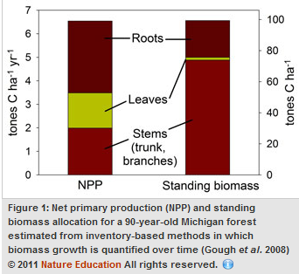
Where do plants invest organic compounds designated for net primary production? Consider, as an example, a mature forest. The stems, leaves, flowers, and fruit are all visible displays of aboveground NPP (i.e., growth) that accrued over time — but what about belowground (root) NPP? Most of the NPP readily observed aboveground is matched in magnitude belowground by the less visible, but equally important, production of roots. For example, root growth comprised almost half of total ecosystem NPP in a ninety-year-old Michigan forest, indicating that belowground investments in biomass by plants are substantial (Figure 1). The total standing biomass of an ecosystem is a function of cumulative NPP over time minus biomass losses from senescence (i.e., death). In the same forest, stems (including trunks and branches) are the largest fraction of standing biomass, but roots comprise a quarter of the total biomass present in the ecosystem.

Terrestrial Primary Production Over Time and Across the Earth's Surface
Terrestrial primary production fluctuates over time and is closely coupled with physical (i.e., abiotic) and ecological (i.e., biotic) changes that play out over different timescales. On scales of seconds to hours, primary production during the growing season responds to environmental drivers of photosynthesis, generally increasing with photosynthetic photon flux density (PPFD) or the spectrum of solar radiation available to power photosynthesis. At the seasonal scale, terrestrial primary production of boreal and temperate ecosystems is tied to changes in temperature and photoperiod, or day length, (Figure 3) while in tropical regions seasonal precipitation patterns often dictate cycles of high and low primary production. Year-to-year, or interannual, changes in terrestrial primary production are often related to long-term climatevariation including prolonged drought and, in some cases, variation from one year to the next in average annual temperature and solar radiation.

Over decades, a period that is meaningful to ecological succession, terrestrial primary production changes in response to shifts in plant competition anddisturbance. Consider an abandoned field that undergoes a successional reversion back to forest. Plant communities will assemble during early succession, with fast-growing plants emerging first and because of low initial plant density there will be little competition for resources. As a result, total plant growth in the ecosystem, or NPP, will proceed at an increasingly higher rate for several years. NPP generally levels off or declines once plants start crowding one another and begin competing more intensively for limiting light, nutrient, and water resources (Figure 3). Terrestrial primary production also may change over time in response to natural disturbances such as insect outbreaks, wind, fire, and pathogens that diminish photosynthesis by reducing leaf biomass and causing plant death. Long-term increases in atmospheric CO₂ and nitrogen deposition associated primarily with fossil fuel burning generally increase plant growth over long periods of time.

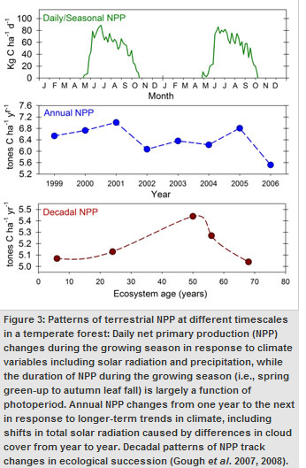
Terrestrial primary production varies considerably across the surface of the Earth and among different ecosystem types. Terrestrial primary production, both NPP and GPP, vary from north to south (or latitudinally) due to gradients in plant community composition, growing season length, precipitation, temperature, and solar radiation. However, east to west (longitudinal) differences in terrestrial primary production also exist. These spatial differences are illustrated in a map of global NPP derived from NASA's MODIS satellite (Figure 4). For example, there is a precipitous decline in NPP from east to west in middle North America that is largely a function of declining precipitation. NPP generally declines from tropical regions to the poles because of temperature and light limitations. Tropical forests tend to be much more productive than other terrestrial ecosystems, with temperate forests, tropical savannah, croplands, and boreal forests all exhibiting middle levels of primary production (Table 1). Desert and Tundra Biomes, limited by precipitation and temperature respectively, contain the least productive ecosystems. In addition to climatic regulation of terrestrial primary production, disturbance, management, and land-use change (including urbanization) play critical roles in determining spatial differences in terrestrial primary production.

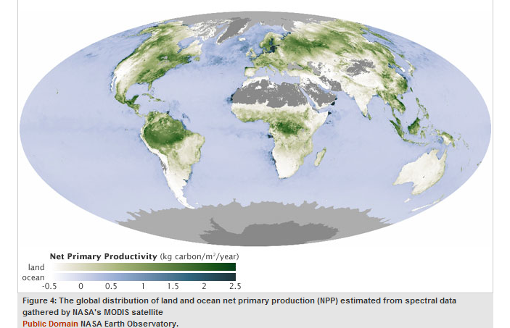

Tropical ecosystems, because of their high productivity and extensive footprint on the Earth's surface, comprise nearly half of global NPP and GPP (Table 1). Temperate ecosystems and croplands are also a substantial fraction of global terrestrial primary production, accounting for roughly a quarter of global NPP and GPP. Global estimates of terrestrial NPP range from 48.0 to 69.0 Pg (= Petagrams or 10¹⁵ g) C yr⁻¹, with global terrestrial GPP estimated at 121.7 Pg C yr⁻¹ or approximately double global NPP on land.

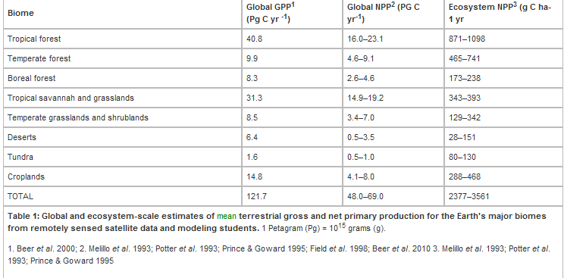

Haberl et al. (2007) estimated that nearly a quarter of global NPP is used by humans annually in the production of crops for food and fiber, timber for wood products and paper, and in support of livestock grazing. Humans exert an additional influence on global NPP through fires. Many ecologists are concerned that the rising global demand for biofuels, together with continued human population growth, will increase this already large human appropriation of global NPP to the detriment of ecological food webs and biodiversity.

Terrestrial Primary Production and Global Change
Considerable research in ecosystem ecology centers on understanding how climate change is affecting the primary production of terrestrial ecosystems and, conversely, how ecosystems may moderate changes in global climate by absorbing anthropogenic CO₂ emissions. Terrestrial primary production is an important ecosystem service, locking up carbon in biomass that might otherwise exist in the atmosphere as CO₂, a potent greenhouse gas. Recent evidence suggests, however, that terrestrial NPP may be declining in response to global warming and accompanying drought, with Zhoa & Running (2010) estimating a 0.55 Pg, or about 1%, reduction in global terrestrial NPP from 2000 to 2009. Continued declines in global NPP would not only reduce carbon sequestration by terrestrial ecosystems but also compromise food security and disrupt the foundation of food webs.

Summary
Ecosystem ecologists have long been interested in quantifying and understanding what controls terrestrial primary production. While gross primary production (GPP) is the total influx of carbon into an ecosystem through the photosynthetic fixation of CO₂, net primary production (NPP) is this gross carbon influx discounted for plant respiratory costs of growth and maintenance. Net primary production forms the base of ecological food chains and is heavily manipulated by humans in the production of food, fiber, wood, and increasingly biofuels. Climate, disturbance, and ecological succession exert influences on terrestrial NPP and GPP, suggesting that mounting anthropogenic influences on global climate and land-use will have substantial effects on the future primary production of terrestrial ecosystems.

