Name: ___________________________________________________________________________________ Pd: _______

Phylogeny Quiz—This is an open note quiz.

- Complete the dichotomous key by writing the number of each organism in the correct blank.
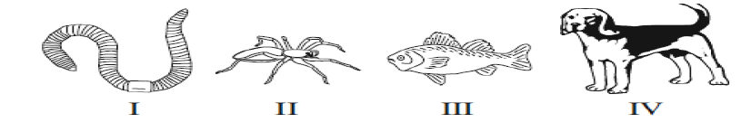
I. A. Legs present…………………………………………………………………………….Go to 2
B. Legs not present………………………………………………………………………Go to 3
II. A. Four legs………………………………………………………………………………..___________________
B. Eight legs………………………………………………………………………………___________________
III. A.Fins………………………………………………………………………………………___________________
B. No fins………………………………………………………………………………….___________________

- The diversity of life we see today is a result of…
A. Extinction
B. Evolution
C. Migration
D. Fossilization
- Which of the following items could become a fossil?
A. Pollen
B. Footprints
C. Bones
D. All of the above
- What kind of information do you get from a phylogenetic tree?
A. The DNA sequence of organisms
B. How different groups of organisms are related
C. An organism’s habitat
D. How many fossils there are of an organism
- Name two pieces of evidence scientists have that suggest all organisms share common ancestors.
- What is a transitional fossil?
Use the phylogenetic tree below to answer questions 5-10.
D
E
C
B
A
Fins

Wings
Fur

Vertebrae

- What species on this tree has fins?
A. A
B. B
C. C
D. A and B
E. B and C
- Which trait is only found in species E?
A. Fins
B. Fur
C. Wings
D. Vertebrae
- What trait does every species on the tree have?
A. Wings
B. Fur
C. Fins
D. Vertebrae
- Species D is most closely related to…
A. Species A
B. Species B
C. Species C
D. Species E
- The arrow on this tree is pointing to…
A. The most recent common ancestor of A and E
B. The most recent common ancestor of B and C
C. The most recent common ancestor of D and E
D. The most recent common ancestor of A and B
- Species E is most closely related to…
A. Species A
B. Species B
C. Species C
D. Species D
Use the map below for questions 11-15. X, Y, and Z are all islands off of the mainland.
There are groups of related turtles that live on these islands.
Mainland

Y
X

Z

- Which island was most likely to have been colonized first by finches from the mainland?
A. X
B. Y
C. Z
- Which island has finches that are most closely related to the finches on the mainland?
A. X
B. Y
C. Z
- Which island has finches that are the most different from the finches on the mainland?
A. X
B. Y
C. Z

- Complete the phylogenetic tree below using X, Y, and Z to represent the finches on the different islands. One has been filled in for you.

Mainland Ancestor

Z

- The finches on island X are most closely related to…
A. Finches on Island Y
B. Finches on Island Z
C. Finches on the mainland
Use the table below to complete the phylogenetic tree. Place all of the organisms and all of the traits on the tree.
Trait | Reptiles | Mammals | Birds
Vertebrae | yes | yes | Yes
Scales | yes | No | No
Lays eggs | yes | no | yes
Wings | no | no | yes
Birds
Does not lay eggs

