Introduction to Ecosystems:
phylogeny

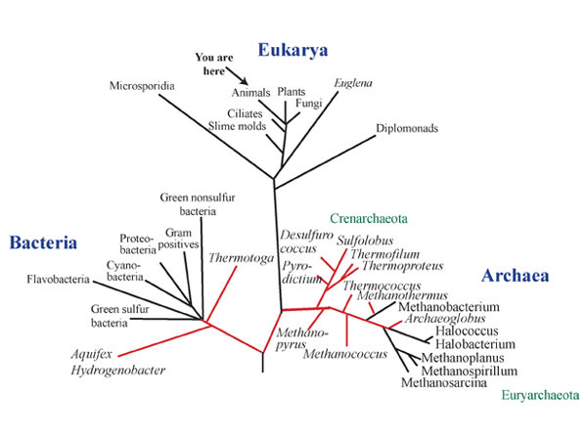

Life Has a History Webquest

- Go to wildebio.weebly.com
- Click on Introduction to Ecological Systems
- Click on the green “Life Has a History” link
- Click on “Level 2”
- Read the instructions for using the site, and then click on the “Next” button in the bottom right-hand corner to start the webquest

Questions
- More than 1,000,000 species alive today are what kind of animal?
- Give one example of a mollusc.
- How many mammal species are known today?
- How many species of fungi are known today?
- Why does this site used different sized pictures to represent arthropods, plants, molluscs, etc?
- The diversity of life we see today is a result of what process?
- Click on the “470 million years ago” picture to read about life in the ancient ocean. What kind of animal was alive then that is a relative of modern squids and octopi?
- What was a trilobite?
- Click on the “160 million years ago” picture. What is the name of the aquatic dinosaur pictured here?
- Click on the “Present” picture. What modern ocean habitat is shown here?
- Complete the timeline activity.
- For each of the three fossils that you click on, write the name of the fossil and its age:
A)
B)
C)
- What four features did early theropods inherit from their ancestors?
- How are the features of the “Birds” different than the features of the “Theropods”?
- What features do the “Modern Birds” have that the “Theropods” did not have?
- What does a cladogram show you?
- Why do different populations of finches have different sized beaks?
- Besides natural selection, what can influence evolution?
- For each of the four extinct species you click on, write the name of the species and when it went extinct:
A)
B)
C)
D)

Family Trees

We can use family trees to represent how individuals in a family are related. On this page, draw your own family tree. Follow the example on the board for the structure of your tree. Be as detailed as you can be! Start with yourself and any siblings you have at the top, and see how far down you can draw the “roots” of your family tree. It’s OK if you don’t know the names of everyone in the older generations of your tree!

Introduction to Phylogenetic Trees

In the family tree you created, you represented the relationship between different biologically related individuals. Scientists use a type of “family tree” to represent the relationships between related species.

A phylogenetic tree is a diagram biologists use to represent the relationship between different groups of organisms. By looking at how groups of organisms are placed in relation to one another in the tree, you can make conclusions about how closely related they are.

The front page of this packet is a large phylogenetic tree. This tree shows the relationship between all of the major groups of living things. Scientists rarely work with trees that large, however. It is usually more helpful to “zoom in” on small pieces of this big tree in order to see more detailed relationships. Below is an example of a smaller tree that just shows the relationships between different vertebrate organisms:

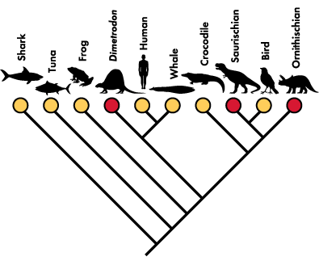

- Every place where two lines intersect is called a node. Draw a star on each node of this phylogenetic tree.
- Every node represents a common ancestor. The common ancestor is an organism that is an ancestor to two or more different groups of organisms. Draw an arrow pointing to the common ancestor of sharks and Ornithischian.
- Draw a circle around the common ancestor of Dimetrodon and humans.
- Birds are most closely related to which organism, according to this tree?
- Humans are most closely related to which organism on this tree?
- Crocodiles are most closely related to which organism on this tree?
- Where on this tree would you find the most recent common ancestor of all of the organisms represented here?
Island Biogeography Notes

What is Biogeography?
- “Bio” means “_________________”
- _____________________________ is the study of ______________________________
- “_________________________________” is the study of where different kinds of __________________________ live
- Biogeography also looks at how the __________________________ of different _________________________ has changed over _________________
- It can tell us a lot about the ______________________ of an _____________________ or a __________________________

Island Biogeography
- Islands are great “_____________________ ____________” for _________________________________
- They are __________________________—any ____________________ living on an _____________________ must have moved to the ______________________ at some point in the past
- _______________________________ on an ______________________ are _____________________ to _______________________________ on the “mainland”
- Over ____________, the population on an ___________________ will begin to ___________ and behave differently than the ___________________ “mainland” population

Colonization
- ________________________________ is the term used to __________________________ the ____________________________ of organisms from the _________________________ to an island
- There are some basic ______________________________ for how ____________________________________ works
- Islands closer to the ________________________________ are more likely to be colonized than ______________________ farther away
- Islands that are _______________________ are more likely to be __________________________ than younger islands
- ________________________ islands are more likely to have _______________________________ of species become ______________________________
- Populations on _________________________ islands are not likely to _______________________________
- Over time, the _________________________ on an island will _____________________ from the population on the ____________________________
  - “Diverge” means “to __________________________” or “to go in another _________________________________”
  - So the ___________________________ populations become ______________________ than the mainland population

Island Biogeography Investigation:
A History of Lizards

The Canary Islands are a group of islands in the Atlantic Ocean, west of Africa. These islands were originally formed by volcanoes and had no forms of life. However, over time, ecological succession occurred on the islands and ecosystems began to form. Because these islands are close to Africa, plant and animal species from the African continent were able to colonize these islands.
- What does “colonize” mean in this context? Write in complete sentences for credit.
There is a group of lizard species living on the Canary Islands. These three species are all different but are related and have similar characteristics. In this investigation, you will construct a phylogenetic tree for these species.
Part 1:
Map 1 on the next page shows you the geography of the Canary Islands, a small group of islands in the Atlantic Ocean off of the coast of Africa. There is a scale on the map that shows you how distance is represented.
- What is the scale on this map for distance? (You will need to use your ruler to answer this question. Measure in centimeters, not inches.)
- Using your ruler, measure the distance between each island and the mainland (Africa). All answers should be in kilometers—you will need to convert centimeters to kilometers using the scale you found in #1. Complete this table.
Island | Distance from Africa (in kilometers)
Lanzarote
Fuerteventura
Gran Canaria
Tenerife
Gomera
Palma
Hierro

- Which of these islands do you think would be the first island to be colonized by species from mainland Africa? Why? Write in complete sentences for credit.
- Which of these islands do you think would be the last island to be colonized by species from mainland Africa? Why? Write in complete sentence for credit.

Part 2:
Find Map 2. Map 2 shows you the biogeography of the three lizard species we are interested in. The scientific names for these species are Gallotia atlantica, Gallotia stehlini, and Gallotia galloti.
- In the table below, write down which lizard species is found on each island.
Island | Species found on island
Lanzarote
Fuerteventura
Gran Canaria
Tenerife
Gomera
Palma
Hierro

- Which of the three lizard species do you think would be most similar to lizards living on mainland Africa? Include specific data in your answer (look back at the first table you completed!), and write in complete sentences.
- Which of the three lizard species do you think would be the most different from the lizards living on mainland Africa? Include specific data in your answer (look back at the first table you completed!), and write in complete sentences.
Part 3:
On the next page is a template of a phylogenetic tree. This diagram is used to illustrate how closely related different groups of organisms are. The three blanks on this phylogenetic tree are for our three different lizard species. At the base of this tree is “African ancestor.”
- What does “ancestor” mean?
- Why are we starting our lizard “family tree” with “African ancestor?”
Next to each blank, there is a number in parenthesis. The number “1” means that the species was the first to “diverge” from the African ancestor—the oldest species, the first to colonize an island. The number “2” means that this species colonized an island after species #1. The number “3” means that the species was the last to colonize an island—the youngest, most recent population.
3. Fill in the blanks on the phylogenetic tree.

African Ancestor
(2)
(3)
(1)

4. We just used geographic evidence to complete the phylogenetic tree. What is geographic evidence? Write in complete sentences for credit.
5. Look at Table 1 (on the same page as Map 2). What information does this table give you about the Canary Islands?
6. Fill in the list below with the names of the islands in order from oldest to youngest. Put the oldest islands in the #1 slot, and put the youngest island in the sixth slot.
1. _______________________________________________________________________
2. _______________________________________________________________________
3. _______________________________________________________________________
4. _______________________________________________________________________
5. _______________________________________________________________________
6. _______________________________________________________________________
7. Now, add the lizard species found on each island to the list in #6.
8. Look over your list of the age of the islands and the species found on each island. Does it support the phylogenetic tree we just created? Why or why not? Write in complete sentences for credit.
Part 4
The figure below shows you the difference in body size between the lizard species on the islands:
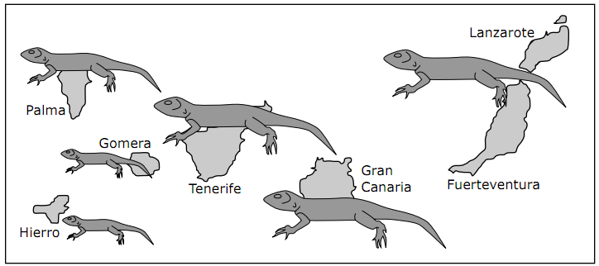
- What is the name of the lizard species with the largest body size? You may need to refer back to your work from Part 2 and the information on Map 2.
- What is the name of the lizard species with the smallest body size?
- The islands Tenerife, Palma, Hierro, and Gomera all have populations of the same species of lizard. Looking at this figure, what do you notice about these four populations of the same species? Write in complete sentences.
- The lizard population on Lanzarote/Fuerteventura is most likely most closely related to the population on which other island?
- Do you think the lizard population on Gran Canaria is more closely related to the lizard population on Tenerife or the lizard population on Hierro? Explain your answer.
- Which of these lizard species do you think is most closely related to the “African ancestor” lizard on the mainland? Why? Write in complete sentences.
- We’re going to do another phylogenetic tree for these lizards. This time, we will split up the species G. galloti into its 4 separate populations. The numbering system on this tree works the same way as the numbering system on our previous tree. Use the morphology (how the lizard looks) data you just analyzed to fill in this tree. A couple of the blanks have been done for you.
African ancestor
G. gallotia (4)
(Palma)
G. stehlini (1)
G. gallotia (3)
(Tenerife)
(6)
(5)
(2)
8. Why were we able to draw a more detailed phylogenetic tree here than we could before? Write in complete sentences for credit.
9. According to this tree, G. stehlini is most closely related to which other species? How can you tell?
G. gallotia (3)
(Tenerife)
G. stehlini (1)

