Name: _________________________________________________________________ Pd: ________
Putting Together a Phylogenetic Tree

This table shows some of the vertebrate characteristics we studied earlier in the quarter:

We can use these traits to build a phylogenetic tree by examining who shares which traits and who has unique traits. Place each vertebrate in the table at the end of a branch on this tree. Label the tree with the traits from the table. We will do this example as a class.

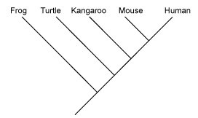

This is a table showing the characteristics of spiders and some related species:
Extra body segment
Legs on abdomen
Exoskeleton like a shield

Below is a tree for these three species. Some of it has been filled in for you. Complete the tree by labeling all of the traits on the tree and placing each species at the end of a branch.

Exoskeleton like
a shield
Extra body
segment
Tracheae
Arachnida

