Name _________________________________ Period ________ Date _____________________________

EVIDENCE OF EVOLUTION
Part I. Morphology

1. Carefully examine the drawings of the bones. Look for similarities among the various animals.

a. COLOR each part of the human arm a different color. (All bones of the wrist should be the same color, the bone groups of the hand should be a different single color.) Then color the corresponding bone in each of the other animals the same color as the human bone.
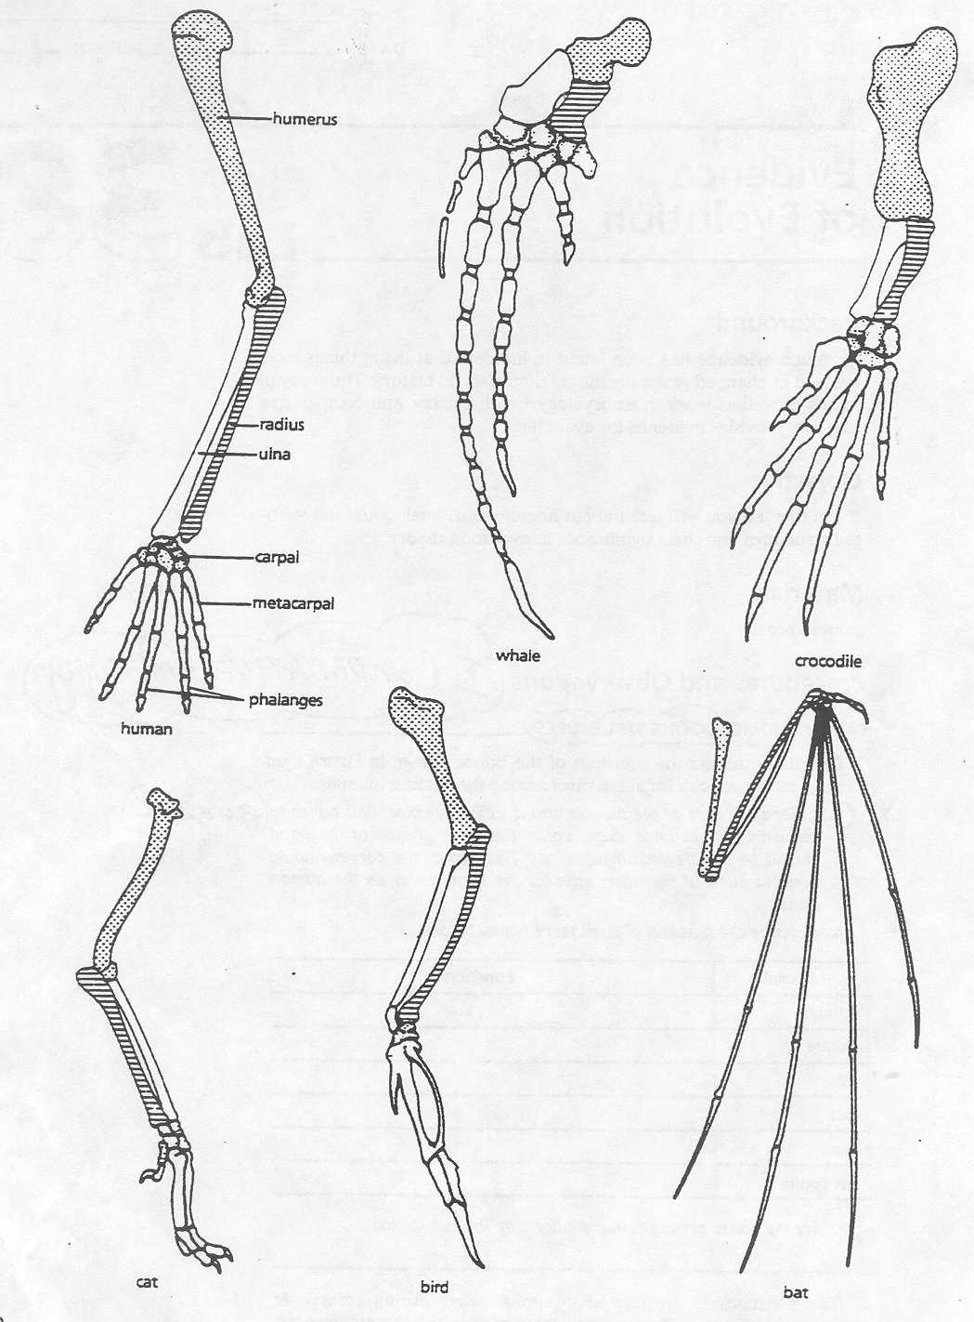

Complete the table below by describing the function of these bones in each animal:
Animal | Function
Human
Whale
Cat
Bat
Bird
Crocodile
These structures are formed in similar ways during embryonic development and share like arrangements:
however, they have somewhat different forms and functions. They are called homologous structures.
1. Explain why the homologous structures of the bones are evidence of evolutionary relationships.
ANALOGOUS STRUCTURES
Refer to the image below for questions 2-4.

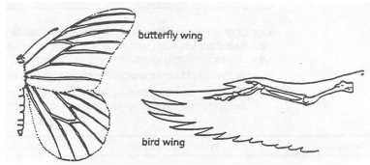
2. What function do these structures share?
3. How do the structures differ?
4. Do birds and insects share any structural similarities that would suggest they are closely related?
Some apparently unrelated animals have organs with similar function, yet are very different in structure and
form. These structures are called analogous structures.

VESTIGIAL STRUCTURES
Gradual changes have occurred through time that have in some cases reduced or removed the function of
some body structures and organs. The penguin’s wings and the leg bones of snakes are examples of this
phenomenon.
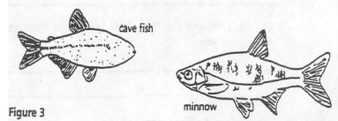
The cave fish and the minnow are related, but the cave fish is blind. Use this information for 5-6.

5. Explain why eyesight is not an important adaptation to life in a cave.
6. Does the appearance of the cave fish and minnow suggest common ancestry? ________________________
Why?
Organs or structures that lost their function in the organism and become reduced in size (because of efficiency)
are called vestigial structures. Human vestigial organs are well documented.
Read the list of human vestigial structures shown below. Suggest a possible function for each structure and
explain why it became vestigial.
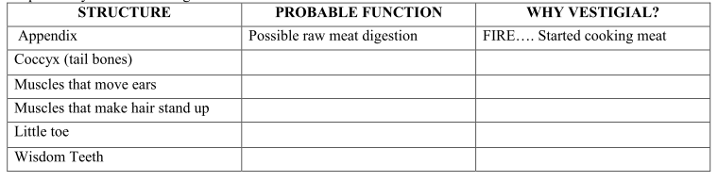
ANALYSIS AND INTERPRETATIONS

7. Explain why the homologous structures of the bones are evidence of evolutionary relationships.

8. Explain the evolutionary relationship between the fin of a fish and the flipper of a whale.

9. How do you think vestigial structures came about?

Part II. EVIDENCE FROM EMBRYOLOGY

Evolution occurs slowly. In most cases, it is not possible to observe evolution in progress. However, evidence of evolution can be found by observing the early stages of development in vertebrates. All vertebrate embryos start out similar in appearance. This similarity has led scientists to think that these organisms have a common ancestor. The diagrams below illustrate stages in the embryonic development of a fish, a pig, and a human.

Study the diagrams below and answer the questions 2 & 3 below.
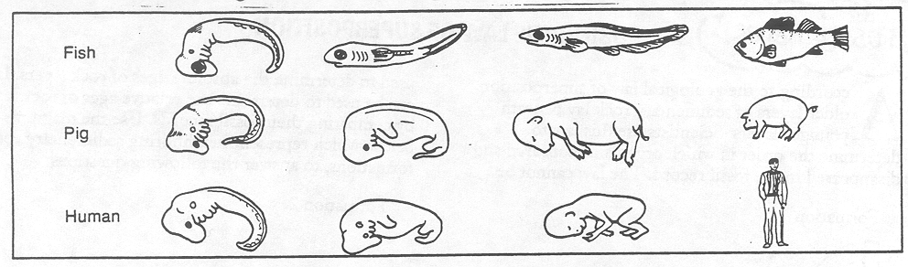

10. How does a comparison of the embryos provide evidence of evolution?

11. Which of the organisms would be most similar to humans: fish or pig? ________________

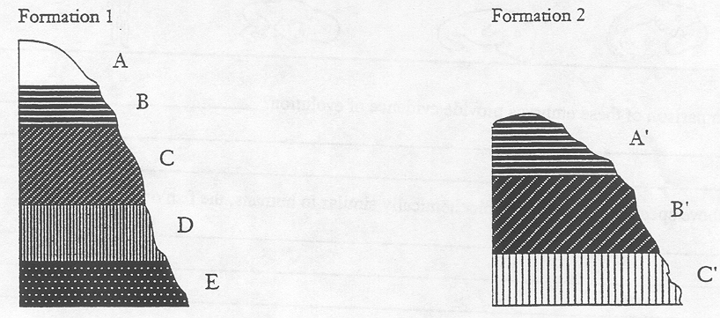
Part III. FOSSIL RECORD

According to the geological law of superposition, older layers of sedimentary rock lay beneath younger layers. Scientists use this law to determine the order in which organisms appeared and disappeared in the fossil record. The law cannot be used to determine the absolute ages of rock layers. It can be used to determine the relative ages of rock layers by comparing their fossil records.

Using the diagrams that represent neighboring sedimentary rock formations, answer questions 4-5. .

12. a. Which layer is the oldest in each formation? ______________________
b. Are the two layers the same age? _______________________________
c. How could you tell?

13. Suppose fossils from layer C’ of Formation 2 are the same as fossils from layer D in Formation 1. What
could you say about the age of fossils from Layer E?

14. Suppose you also found that layers C and B’ shared similar fossils. Layers B and A’ look very similar, but
contain no fossils. What could you say about the relative ages of all layers of both formations?

15. Suggest one geological event that might explain why Formation 2 has fewer layers than
Formation 1.
Part IV. Molecular Biology
Amino acid sequences of certain proteins can be used to determine how closely related different species are. If
the amino acid sequences for a certain protein are very similar in two species, one can assume that those two
species had a common ancestor. All 104 amino acids in the protein cytochrome c are identical in humans and
chimpanzees.
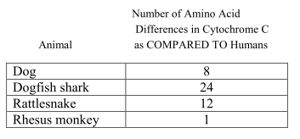
16. How does this chart provide evidence for evolution?

