Names: __________________________________________________________________________________ Pd:________

Identifying Biomes Using Climatographs

A climatograph is a graph that describes the temperature and precipitation trends for a particular geographic location. Below is an example of a climatograph:
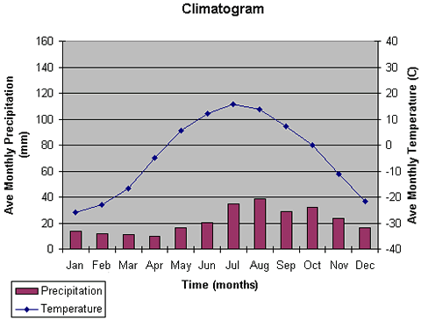

Using the data provided, create a climatograph for Biome A and for Biome B. Compare your climatograph to the descriptions of different biomes and identify which biomes you have. Temperatures below are in Fahrenheit and precipitation is in inches.

Biome C | Month | Jan | Feb | Mar | Apr | May | Jun | Jul | Aug | Sep | Oct | Nov | Dec
 | Precip. | 0.18 | 0.15 | 0.14 | 0.17 | 0.15 | 0.32 | 0.87 | 0.98 | 0.63 | 0.47 | 0.24 | 0.16
 | Temp. | -13.9 | -17.7 | -15.0 | -2.2 | 19.4 | 33.9 | 39.2 | 37.8 | 30.6 | 13.6 | -1.6 | -11.2

Biome D | Month | Jan | Feb | Mar | Apr | May | June | July | Aug | Sep | Oct | Nov | Dec
 | Precip. | 3.3 | 3.4 | 3.7 | 3.1 | 3.6 | 3.8 | 4.6 | 4.3 | 3.7 | 3.0 | 2.7 | 3.3
 | Temp. | 38.3 | 40.2 | 48.0 | 57.9 | 66.6 | 74.1 | 77 | 75.9 | 70.0 | 58.5 | 48.2 | 39.9

Once you have created your two graphs, use your textbook (652-659) to identify which two biomes are depicted by your climatographs.

