Names: __________________________________________________________________________________ Pd:________

Identifying Biomes Using Climatographs

A climatograph is a graph that describes the temperature and precipitation trends for a particular geographic location. Below is an example of a climatograph:
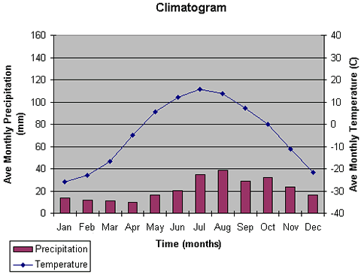

Using the data provided, create a climatograph for Biome A and for Biome B. Compare your climatograph to the descriptions of different biomes and identify which biomes you have. Temperatures below are given in Fahrenheit and precipitation is in inches.

Biome A | Month | Jan | Feb | Mar | Apr | May | June | July | Aug | Sep | Oct | Nov | Dec
 | Precip. | 0.01 | 0.03 | 0 | 0.01 | 0.04 | 0.02 | 0.03 | 0.15 | 0.05 | 0.08 | 0 | 0
 | Temp. | 62 | 46 | 65 | 78 | 84 | 97 | 102 | 90 | 89 | 77 | 70 | 62

Biome C | Month | Jan | Feb | Mar | Apr | May | Jun | Jul | Aug | Sep | Oct | Nov | Dec
 | Precip. | 0.18 | 0.15 | 0.14 | 0.17 | 0.15 | 0.32 | 0.87 | 0.98 | 0.63 | 0.47 | 0.24 | 0.16
 | Temp. | -13.9 | -17.7 | -15.0 | -2.2 | 19.4 | 33.9 | 39.2 | 37.8 | 30.6 | 13.6 | -1.6 | -11.2

Once you have created your two graphs, use your textbook (652-659) to identify which two biomes are depicted by your climatographs.

