Name: _______________________________________________________________________ Pd: ________
Introduction to Ecological Systems
Change over Time:
Speciation, Natural Selection, and Evolution
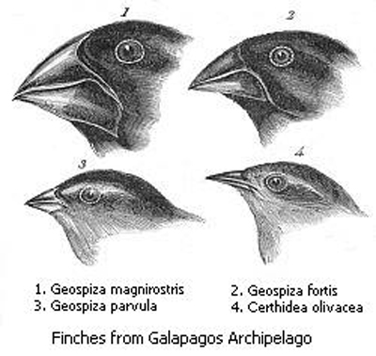

Speciation
Write your definition of the word “species” in the space below:
Write the class’s definition of the word “species” in the space below:
Case Study: Crickets
This case study begins with a population of crickets living in southwestern PA. During mating season, male crickets chirp songs in order to attract female crickets. Female crickets in this population mate with males who have long, loud songs. Males who chirp well are able to mate successfully; males who do not chirp well have difficulty finding a mate. The male crickets generally chirp at night, which is when female crickets are looking for mates.

An endangered species of owl is introduced into the crickets’ habitat. Researchers are hoping that this habitat will be good for the endangered owls and that moving the owls here will increase the number of owls. These owls eat mostly insects. Since owls are active at night, they are able to find the crickets by listening for the mating songs. Male crickets chirping loudly at night are the first crickets to be eaten by the owls. As a result, the only male crickets left for the females to mate with are the few males that either chirp quietly or chirp during the day. After several generations of crickets living with the owl predators, nearly all male crickets chirp softly during daylight.

Biologists notice this odd cricket behavior and are interested in finding out whether these daytime-chirping crickets are a different species than common night-time chirping crickets. They capture several males and females of the daytime-chirping crickets and put them in a very large glass tank along with some males and females of night-time chirping crickets. This large glass tank is placed in a window so that the crickets are exposed to natural cycles of day and night. The biologists notice that the two types of crickets look identical but are active at different times. Researchers observe these crickets carefully, and no females from the daytime-chirping population mate with males from the night-time chirping population.

Questions:
- Describe the starting population of crickets. How did these crickets find mates?
- What changes in the crickets’ environment?
- How does the change from question #2 affect the crickets?
- After several generations, how has the mating behavior of the crickets changed?
- Why might biologists think that these crickets are a different species from the usual night-time chirping crickets?
- When the daytime-chirping crickets are put in a glass tank with night-time chirping crickets, what do the biologists notice about the two groups of crickets?
- Why don’t the daytime-chirping crickets mate with the night-time chirping crickets?
- Did you expect that the different chirping times would make a difference in mating between the two groups? Explain.
- Are these two groups of crickets different species? Explain your answer.
- Suppose that the owls are removed from the crickets’ habitat. Do you think that the daytime-chirping crickets would continue to chirp during the day, or would they begin chirping at night again? Explain your answer.

Case Study: Iguanas
This case study begins with a population of iguanas living on a tiny island in the Pacific Ocean. The iguanas live near the shore, and they eat mostly leaves from local shore plants. These leaves are broad and tough, and the iguanas have flat teeth to help them grind the leaves. The iguana population is pretty small—there are only about 100 individuals on the island.
One day, a huge hurricane hits the island. About a dozen iguanas are blown off-shore. These iguanas survive by clinging to a drifting log. The iguanas ride this log raft for several days, until it lands on another island. This island has a much drier climate than the iguanas’ homeland, and there are no local plants growing along the shore for the iguanas to eat. In search of food, the iguanas move inland to a forest on the island. Here, they find an abundance of dandelion, which they begin to eat. The dandelion leaves are much smaller and less tough than the leaves the iguanas ate on the first island. Individuals with smaller, sharper teeth can eat the dandelion more successfully because they can tear the leaves more easily.

After several generations, the iguanas on the second island have mostly small, sharp teeth. The iguanas on the first island still have flat teeth. Biologists notice this and are interested in determining whether or not these two populations of iguanas are different species. A research team captures a small group of male and female iguanas from the second island, tags them, and releases them onto the first island. The tagged iguanas do not stay on the shore, but move inland to the island’s small patch of grassland. Here, there are dandelion-like plants for the iguanas to eat. During mating season, none of the dandelion-eating iguanas mate with the shore iguanas—there is no contact between the two groups.

Questions:
- Describe the starting population of iguanas.
- How does a small group of iguanas get separated from the population?
- How is the second island different from the first island?
- How does the different food source affect the iguana population?
- After several generations, how is the iguana population on the second island different from the iguana population on the first island?
- Why might the biologists think that these two groups of iguanas are different species?
- When the iguanas from the second island are put back on the first island, what do they do?
- Is the answer to #7 what you expected to happen?
- Why don’t the tagged iguanas mate with the shore iguanas?
- Are these two groups of iguanas different species? Explain your answer.

Comparing the Case Studies

With a partner, create a poster comparing these two case studies. Your poster needs to address the following questions:
- Which of these case studies do you think describes the formation of a new species? Your answer could be Case #1, Case #2, both, or neither. Explain your answer.
- Thinking about your answer to question #1, how much change do you think needs to happen in order for two groups of organisms to truly be different species?
- Describe a scenario that could cause a single population of organisms to split into two different species. Keep in mind that new species form over time, not instantly.

In the space below, write down the three different definitions biologists use for the word “species:”
- Biological species concept:
  - Why it works:
  - Why it doesn’t work:
- Morphological species concept:
  - Why it works:
  - Why it doesn’t work:
- Phylogenetic species concept:
  - Why it works:

A STEP IN SPECIATION
The Analysis of Field Observations
Adapted from Investigation 9.4 in Biological Science - An Ecological Approach
(BSCS Green Version), 1987, Kendall/Hunt Publishing Co.

BACKGROUND: The small salamanders of the genus Ensatina are strictly
terrestrial. They even lay their eggs on land. Nevertheless, these salamanders
need a moist environment and do not thrive in arid regions. In California, the
species Ensatina eschscholtzii has been studied by R.C. Stebbins at the University
of California (Berkeley). This investigation is based on his work.

PROCEDURE, PART A COLLECTION AREAS:
1. Imagine that you are working with Stebbins' salamander specimens, some of which
are pictured on the colored sheets provided.
a. In the list below, the salamanders are identified by subspecies (a subspecies is
a geographically restricted population that differs consistently from other
populations of the same species). For example, the first one is Ensatina
eschscholtzii croceator, shortened to E.e. croceator. "croceator" indicates
a particular subspecies population of Ensatina eschscholtzii.
b. The parentheses after each subspecies name contain a number and a color.
The number is the total of individuals Stebbins had available for his study.
The color is the one you should use for that subspecies when you plot its
collection area on the California map.

c. Following the parentheses is a list of grid codes indicating where (on the map
grid) the subspecies was collected. For example, 32/R means that one or
more specimens were collected near the intersection of horizontal Line
32 and vertical Line R.

d. The letter before the subspecies name indicates the corresponding salamander
picture on the color sheet. For example, E.e. eschscholtzii is picture b on
the color sheet.
a . E.e. croceator (15; brown): 32/R, 32/S, 30/T, 31/T
b . E.e. eschscholtzii (203; red): 30/M, 32/O, 34/S, 35/V, 36/W, 35/Z, 38/Y, 40/Z
c . E.e. klauberi (48; blue): 36/Z, 38/a, 39/a, 40/a
d . E.e. oregonensis (373; purple): 9/B, 7/E, 6/E, 13/C, 10/C, 7/D, 15/D
e . E.e. picta (230; yellow): 2/B, 2/C, 3/C, 4/C
f . E.e. platensis (120; green): 8/J, 10/J, 11/M, 13/M, 15/M, 15/O, 17/M, 15/P, 20/Q,
24/S, 21/R, 25/T, 26/U
g . E.e. xanthoptica (271; orange): 17/G, 17/F, 19/H, 19/O, 20/I, 20/J, 21/I
2. Plot each collection area by filling in the corresponding square on the California
map grid. Color in the square above and to the left of the point where the
specified grid coordinates cross. For example, the square in the upper left-hand
corner is 1/A. Use the colors indicated for each subspecies population (listed
above) to make a distribution map of Ensatina eschscholtzii in California.

3. Answer the Discussion Questions for Part A, based on your work and
interpretations, and your discussions with partners.

Questions for Part A:
- Is the species uniformly distributed? Use your knowledge of the species' ecological
requirements (see "Background") to offer an explanation of its distribution.
Are there any other factors that might affect distribution?
- Consider the geography of California. Does the species seem more characteristic
of mountain areas, or of valley areas?
3. Do you expect any pattern in the distribution of subspecies? Why or why not?
4. Examine the salamanders on the color sheet (or the cutouts in the envelope, if
provided). Note that some subspecies have yellow or orange spots and bands on
black bodies. Some have fairly plain, brown-orange bodies. One has small
orange spots on a black background. There are other differences as well: for
example, some of them have white feet. Now refer to your distribution map.
Does there appear to be any order to the way these color patterns occur in
California? For example, do the spotted forms occur only along the coast? Do
spotted forms occur in the north and unspotted ones in the south? What DO you
find? (If the colored salamanders have been cut apart and provided to you in an
envelope, arrange them in their appropriate areas. This should make
comparisons, trends, and patterns easier to see).
5. Subspecies E.e. eschscholtzii (specimen b) and E.e. klauberi (specimen c) are
different from each other. What relationship is there between their
distributions?

PROCEDURE, PART B COLLECTION AREAS:
1. You may wonder if there are salamanders in some areas for which you have no
records. You also may wonder if there might be additional subspecies for
which you have no specimens. A biologist faced with these questions would
leave the laboratory and go into the field to collect more specimens. Imagine
that you have done this and returned with the following data:

b . E.e. eschscholtzii (16; red): 36/Z, 41/Z, 33/M, 34/W, 34/U
c . E.e. klauberi (23; blue): 40/b, 40/Z, 36/a
h . Unidentified population 8 (44; pink): 4/I, 5/H, 7/H, 7/F, 6/J, 9/F
i . Unidentified population 9 (13; burgundy): 28/T, 27/T, 26/T, 28/S, 29/T
k . Unidentified population 11 (131; turquoise): 23/J, 24/K, 24/I, 29/M, 25/J, 25/I
l . Unidentified population 12 (31; black): 6/C, 7/C, 6/B

2. Mark with the color gold the following places that were searched for Ensatina
without success:
11/I, 14/I, 17/K, 22/N, 26/Q, 5/M, 32/U, 32/a, 35/f

Specimens of populations 8 (specimen h) and 9 (specimen i) are shown in the
color pictures. (There are no illustrations for populations 11 and 12).

3. Answer the Discussion Questions for Part B, based on your work and
interpretations, and your discussions with partners.

Part B Discussion Questions:
1. Why is it unlikely that you would ever find individuals combining characteristics of E.e. picta and E.e. xanthoptica ?

2. Look at the distribution of the original collections of E.e. eschscholtzii and E.e. klauberi. What reasons were there for trying to collect additional specimens from extreme southwestern California?

3. How do the results of the additional collections differ from the results in other places where two different populations approach each other?

4. Bear in mind the biological definition of a species and also the appearance and distribution of the named populations of Ensatina. Which one of these populations could be considered a species separate from E.e. eschscholtzii ?
7. Now imagine that, while examining salamanders in another collection, you find specimen j from population 10, shown in the colored photo. Compare its characteristics, especially the spotting pattern, with those of the named populations. Also, consider the distribution of these populations. Between which two populations is this specimen most likely a hybrid? On your map, draw a line where you might expect to collect other specimens like this one.
8. In a brief paragraph, explain why you think Stebbins concluded that there is only one species of Ensatina in California.
9. Suppose that volcanic activity in northern California should become violent and completely destroy all the salamanders in that region. How would this event affect the species Ensatina ?

Natural Selection Notes

What is Natural Selection?
- In a _______________________________ of _____________________, individuals who are best ____________________ to their ____________________________ will survive and _______________________________ more successfully than others
- This leads to a ______________________ in a ___________________________________ over _______________
- _____________________ that are ________________________________________—that help ___________________________ survive in an ___________________________________—will become more _______________________ in a population over _____________________

Conditions for Natural Selection
- There is _________________________ in a ______________________________
  - Individuals are ______________________ from one another
- Variation is ____________________________
  - _______________________ pass on ____________________ to offspring
- This ______________________________ causes some __________________________ to survive and ____________________________ better than others

Adapted from On the Origin of Species by Charles Darwin
...We behold the face of nature bright with gladness, we often see an [abundance] of food; we do not see, or we forget, that the birds which are singing round us mostly live on insects or seeds, and are thus constantly destroying life; or we forget how often these birds, or their eggs, or their offspring, are destroyed by predators. We do not always bear in mind, that though food might be abundant now, it is not always available.

The phrase ‘Struggle for Existence’ can be used in a broad sense. It describes not only an individual organism’s fight to survive, but also—and more importantly!—the individual’s ability to reproduce. If food is scarce, two dogs will fight one another for the opportunity to eat and survive. Similarly, a plant on the edge of a desert struggles against other plants for water. This plant might produce a thousand seeds, and perhaps only one of those seeds might grow to maturity. Each seed must fight against other seeds and plants for water.

A struggle for existence follows directly from the high rate of reproduction among organisms. Because more individuals are produced than can possibly survive, there must be competition for survival. Otherwise, the earth would quickly run out of resources. If every individual organism that was produced survived to maturity, the earth would soon be covered by all of the offspring of single mating pair. Consider this: if there was a plant that produced only two seeds a year, and both of those seeds grew into mature, reproducing plants, then within twenty years there would be a million of those plants. Although some species do experience increases in numbers, not all species can do so at once.

The amount of food available ultimately limits the number of individuals within a species that can survive and reproduce. Being hunted and eaten by other organisms also limits the size of a species. In addition, climate and environmental conditions play a large role in determining the number of individuals in a species. When conditions are favorable, there will be more successful individuals in a species. If conditions are harsh, fewer individuals will be able to survive and reproduce. Finally, illness and disease also have an effect on the survival of individuals within a species.

We know that there exists variation within a species. Not all individuals within a species take the same form. It is reasonable to assume, therefore, that individuals having any advantage, however slight, would have the best chance of surviving and reproducing. Furthermore, we can assume that any individuals with harmful variations would not be able to survive. The preservation of favorable, advantageous variations can be called Natural Selection.

When we notice that leaf-eating insects are green, that bark-eating insects are gray, and that Arctic birds are white, we can be sure that those colors are advantageous for those individuals and contribute to their survival. There is no reason to doubt that natural selection would be most effective in preserving the beneficial color within each species.

That natural selection will always act with extreme slowness, I fully admit. Nothing can be affected unless favorable variations occur, and variation itself is a slow process. This very slow rate of natural selection agrees perfectly well with what geology tells us about the rate at which the world was formed and changed.

I can see no limit to the amount of change, to the beauty and infinite complexity of the co-adaptations between all organisms, which may be caused over a long course of time by nature’s power of selection.

adapted from The Greatest Show on Earth (2009) by Richard Dawkins

...Only a theory? Let’s look at what theory means. The Oxford English Dictionary gives two meanings:

Theory, Meaning #1: A scheme or system of ideas or statements held as an explanation or account of a group of facts or phenomena; a hypothesis that has been confirmed or established by observation or experiment, and is accepted as accounting for the known facts; a statement of what are accepted as the general laws, principles, or causes of something known or observed.

Theory, Meaning #2: A hypothesis proposed as an explanation; hence, a mere hypothesis, speculation, conjecture; an idea or set of ideas about something; an individual view or notion

Obviously these two meanings are very different from one another. One excellent example of Meaning #1 is the Heliocentric Theory, which explains that the Earth revolves around the sun. This is a theory which is well-supported by observation and evidence. Similarly, scientists are using Meaning #1 when they talk about evolution. Darwin’s theory of evolution by natural selection fits Meaning #1 perfectly—it is a “hypothesis that has been confirmed or established by observation or experiment, and is accepted as accounting for the known facts.”

In the history of science, theories start off as hypotheses. Like the Heliocentric Theory, a hypothesis may be ridiculed when it is first proposed before it progresses to the status of theory through the collection of evidence. People used to think the sun was smaller than the Earth because they had inadequate evidence. Now we have evidence that the sun is much larger than the Earth. For Darwin, writing in the 1850s, the theory of evolution by natural selection was tentative, hypothetical; he did not have the abundance of compelling evidence scientists have today. Over the last 150 years scientists have collected evidence that pushes Darwin’s ideas from only a hypothesis to a “hypothesis that has been confirmed or established by observation or experiment, and is accepted as accounting for the known facts.”

Reading Questions

1. According to Charles Darwin, what do we often “forget” when we look at nature?

2. What is the phrase ‘Struggle for Existence’ used to describe?

3. What does Darwin think causes the struggle for existence?

4. What would happen if every organism that was produced survived to maturity?

5. Name three things that have an effect on how many individuals within a species survive.

6. What does Darwin say about individuals who have a variation that gives them an advantage?

7. How does Darwin define Natural Selection?

8. Why does Darwin say that natural selection will always act slowly?

9. What do you think is the most important difference between the two definitions of theory used by Richard Dawkins? [Do not say that one is longer!]

10. Besides Darwin’s theory of evolution by natural selection, what example does Dawkins give of a theory that fits Meaning #1?

11. In science, how does a hypothesis become an accepted theory?

Charles Darwin Notes
Charles Darwin
- British, born in 1809 to a wealthy family
- Spent his childhood fascinated by nature—he had _________________________ of insect specimens
- His father sent him to _________________________ school; Darwin wasn’t interested and spent his time at med school working on ___________________________ history research
- He was then sent to Cambridge to begin studying for the __________________________________
- Had no real interest in becoming a minister and went on the __________________________ instead

H.M.S. Beagle
- The Beagle was an ________________________________ voyage that left _______________________ in 1831
- Darwin joined the crew as a “______________________________”
- Over the five-year voyage, Darwin collected _______________________ samples and ______________________ specimens for study
- Beagle traveled around the whole coast of South America, the Galapagos Islands, and northwestern Africa

Natural Selection
- The _________________________ Darwin observed and collected, as well as the _____________________ he discovered, made him _____________________ about how all of these different __________________ were formed (i.e., seashells on mountains, etc)
- He wasn’t the first person to think about biological _____________________________
- As __________________ became more well-understood (the _______________ changed over ___________), the concept of biological ________________________________ gained more ________________________________________
- Darwin is notable for being the first to suggest ______________________________ ____________________________
- Natural Selection was the first serious _______________________________ proposed for how ___________________________ might occur
- Darwin wasn’t the only _______________________________ on it, either
- Alfred Russell Wallace had ___________________ ideas, and when Darwin realized that, he rushed to finish writing his _________________ and published __________________
- __________________________________________ was published in 1859

The Peppered Moth Population, 1800-1810
In the early 1800s, scientists began surveying the peppered moth population in northern England. They noticed two different versions of moth: one variety was light colored and one variety was dark colored. From 1800-1810, here’s the data the scientists collected:
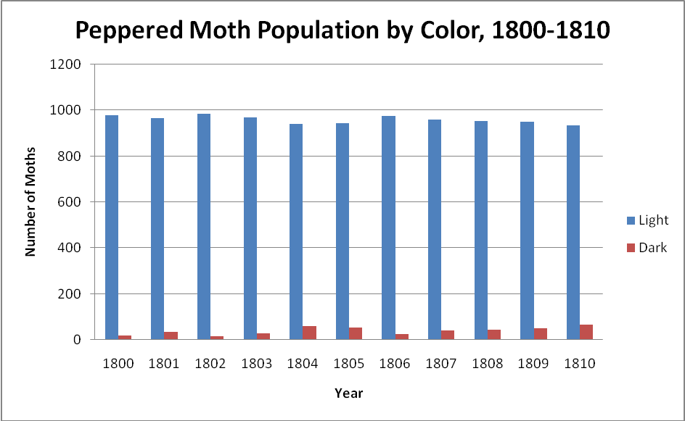
- What do you notice about the numbers of the two moth varieties?

- Why might one color be more common than another color?

- Does the population seem to be changing during this time period?

The Peppered Moth Population, 1855-1865
In the early 1800s, scientists began surveying the peppered moth population in northern England. They noticed two different versions of moth: one variety was light colored and one variety was dark colored. Here’s an example of the type of data scientists collected on the population between the years 1855 and 1865:
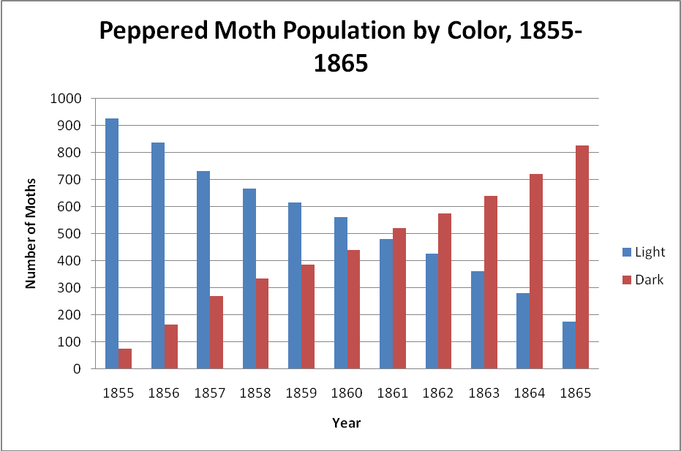
- What do you notice about the numbers of the two moth varieties?

- Why might one color be more common than another color?

- Does this population seem to be changing? How so?

Air Pollution in England, 1800-1870
During the 19th century (1800s), industrialization took hold in northern England. This meant that the number of factories increased significantly. Factories became much more common and started to make up most of the country’s economy. But factories produced more than goods. This graph details how the amount of air pollution changed during this period of England’s history:
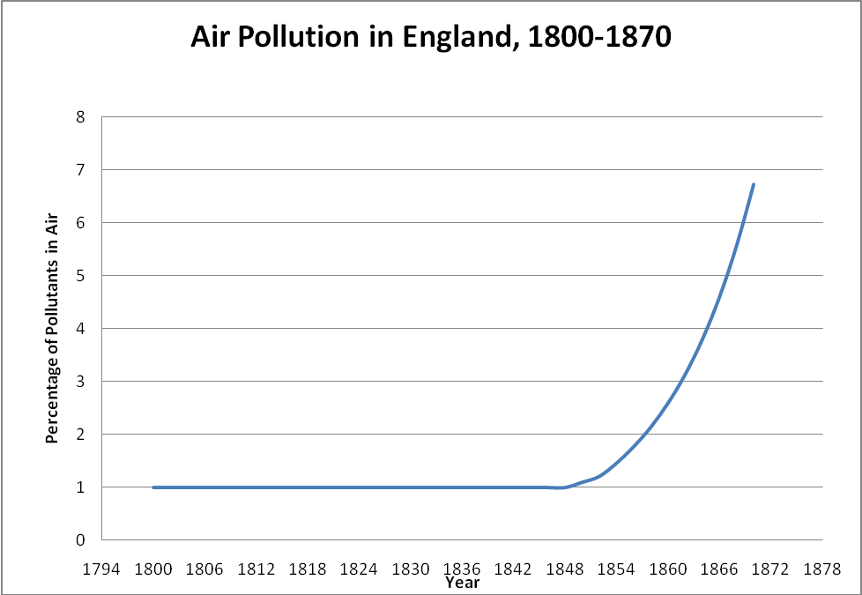
- Describe the general pattern depicted by this graph. Can you explain why this pattern exists?

- What kinds of effects might pollution have on the environment?
Camouflage
These two pictures show two different peppered moths on a tree. The picture on the left is from 1842. The picture on the right is from 1878.
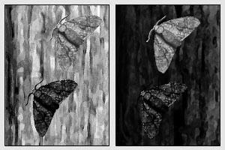
- Describe the difference between these two pictures.
- Why is the tree on the right darker than the tree on the left?

- Why do you think moth color might be significant?

Explaining the Data
On the next page, write a paragraph that explains what is happening to the peppered moth population. Your paragraph must include an explanation of each piece of data—the numbers of different moths, the pollution, and how moth color affects survival.

Peppered Moths Paragraph:
_____________________________________________________________________________________________________________________________________________________________________________________________________________________________________________________________________________________________________________________________________________________________________________________________________________________________________________________________________________________________________________________________________________________________________________________________________________________________________________________________________________________________________________________________________________________________________________________________________________________________________________________________________________________________________________________________________________________________________________________________________________________________________________________________________________________________________________________________________________________________________________________________________________________________________________________________________________________________________________________________________________________________________________________________________________________________________________________________________________________________________________________________________________________________________________________________________________________________________
Revised Paragraph:
___________________________________________________________________________________________________________________________________________________________________________________________________________________________________________________________________________________________________________________________________________________________________________________________________________________________________________________________________________________________________________________________________________________________________________________________________________________________________________________________________________________________________________________________________________________________________________________________________________________________________________________________________________________________________________________________________________________________________________________________________________________________________________________________________________________________________________________________________________________________________________________________________________________________________________________________________________________________________________________________________________________________________________________________________________________________________________________________________________________________________________________________________________________________________________________________________________________________________________________________________________________________________________________________________________________________________________________________________________________________________________________________________________________________________________________________________________________________________________________________________________________________________________________________________________________________________________________________________________________________________________________________________________________________________________________________________________________________________________________________________________________________________________________________

