A Brief History of the Cell (18 pts)
WRITE IN COMPLETE SENTENCES FOR FULL CREDIT.
- The term “aerobic” means “with oxygen.” Anaerobic means “without oxygen.” Organisms that are aerobic use oxygen; organisms that are anaerobic do not use oxygen. Many organisms can function either aerobically or anaerobically depending on the environment. Humans, for example, can survive anaerobically for a couple of minutes. However, there are some organisms that are strictly aerobic or strictly anaerobic.
Anaerobic organisms and aerobic organisms use different reactions to get energy from their environment.These different sets of reactions have different results.
What conclusions can you draw from this graph? (2 pts)
Who would you expect to be more successful—anaerobic organisms or aerobic organisms? Explain. (2 pts)

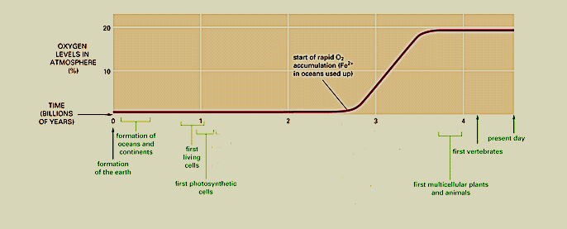
This graph shows the change in the amount of oxygen in the Earth’s atmosphere over time.
Which type of organisms do you think came first—anaerobic or aerobic? Explain your answer. (2 pts)
Were these first organisms prokaryotes or eukaryotes? (1 pt)
After there was more oxygen in the atmosphere, which type of organisms would have been more successful—anaerobic or aerobic? Explain. (2 pts)

- What happens during endocytosis? (2 pts)
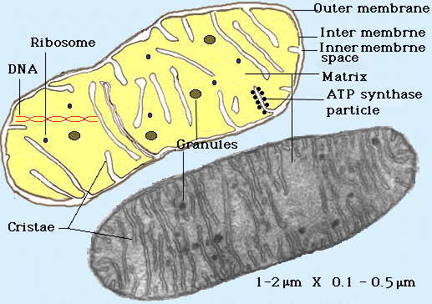
This is a picture of a mitochondrion. The bottom image is a micrograph; the top image is an artist’s rendition. Mitochondria are found in eukaryotic cells. They have a double membrane, their own DNA, and ribosomes. Furthermore, mitochondria can divide and replicate on their own, independent of the rest of the cell. Mitochondria use oxygen to run the reactions that generate ATP for the cell. Cells need ATP to power biochemical reactions.
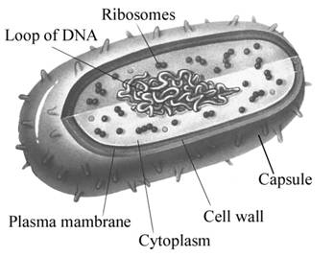
This is an image of a prokaryotic cell. Prokaryotes generally reproduce by dividing into two identical daughter cells.
- Describe at least two differences and two similarities between mitochondria and prokaryotes. (2 pts)
- On the back of this sheet, propose an explanation for the origin of mitochondria in eukaryotic cells. Cite specific evidence in your explanation. (5 pts)

Alberts B, Johnson A, Lewis J, Raff M, Roberts K, Walter P. 2002. Molecular Biology of the Cell. 4th ed. New York: Garland Science. Accessed via the National Center for Biotechnology Information: http://www.ncbi.nlm.nih.gov/bookshelf/br.fcgi?book=cell&part=A25.

