Name: _________________________________________________ Pd: _______

Mitosis Practice

- Draw and label a homologous pair of replicated chromosomes.
centromere
chromatid

- A human body cell has 46 chromosomes. Use this information to answer the following (4 pts):
How many chromatids in prophase? _92______
How many centrioles in anaphase? ____2____
How many total chromosomes in telophase? __92____
How many centromeres in metaphase? __46_____
- A fruit fly cell has 8 chromosomes. Use this information to answer the following (4 pts):
How many chromatids in metaphase? __16__
How many centromeres in prophase? __8__
How many chromosomes in anaphase? __16__
How many centrioles in telophase? ___2___
- Do sister chromatids have identical genetic information? How do you know? (3 pts)
Sister chromatids have identical genetic information. This is true because the sister chromatids are each part of the same replicated chromosome. DNA replication ensures that the chromatids are identical.
- A cell with 6 chromosomes enters mitosis. Draw a picture of this cell at anaphase (4 pts). Label the centrioles, spindle fibers, and chromosomes.
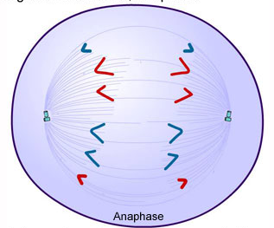
- Why is cytokinesis not technically a phase of mitosis? (2 pts)
Mitosis is nuclear division; cytokinesis is cell division.
- Put the following events of mitosis in chronological order from 1-5:
Chromosomes line up in the middle of the cell __3___
Spindle fibers attach __2 (or 1)______
Centromeres divide and sister chromatids separate __4_____
Nuclear envelope dissolves _1 (or 2)______
Nuclear envelope reforms ___5______

- How are sister chromatids different from a homologous pair?
Sister chromatids are genetically identical; homologous pairs are genetically similar. Two sister chromatids comprise a single replicated chromosome, while one homologous pair contains two individual, distinct chromosomes.
- Two biologists are arguing about the phases of mitosis. They see the following cell under a microscope:
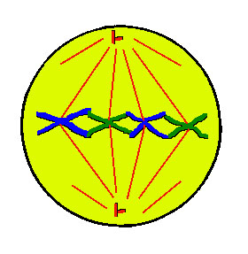
Brittany thinks this cell in in prophase but Nikki claims it is in metaphase. Who is correct and how do you know? (4 pts)
This is metaphase. The line of chromosomes along the metaphase plate is the key feature of metaphase.
- Identify the phase during which the following things happen (8 pts):
Centromeres divide ______ana-________________
Nuclear envelope dissolves ___pro-__________________
Chromosomes line up across the middle of the cell ______meta-__________________
Spindle fibers form ___pro-__________________________
Nuclear envelope reforms _telo-_____________________________
Chromatids split apart __ana-_____________________________
Spindle fibers attach ____pro-_____________________________
DNA condenses into visible chromosomes ___pro-_________________________
- Why are there zero chromatids during anaphase and telophase? (2 pts)
When the replicated chromosomes split apart, each chromatid becomes a chromosome.
- Would mitosis work without the spindle fibers? Why or why not? (3 pts)
No—you need spindle fibers to move the chromosomes around and to ensure that each daughter nuclei gets one copy of every chromosome.

