Name: _________________________________________________ Pd: _______

Mitosis Practice

- Draw and label a homologous pair of replicated chromosomes.

- A human body cell has 46 chromosomes. Use this information to answer the following (4 pts):
How many chromatids in prophase? _______
How many centrioles in anaphase? ________
How many total chromosomes in telophase? ______
How many centromeres in metaphase? _______
- A fruit fly cell has 8 chromosomes. Use this information to answer the following (4 pts):
How many chromatids in metaphase? ____
How many centromeres in prophase? ____
How many chromosomes in anaphase? ____
How many centrioles in telophase? ______
- Do sister chromatids have identical genetic information? How do you know? (3 pts)
- A cell with 6 chromosomes enters mitosis. Draw a picture of this cell at anaphase (4 pts). Label the centrioles, spindle fibers, and chromosomes.
- Why is cytokinesis not technically a phase of mitosis? (2 pts)
- Put the following events of mitosis in chronological order from 1-5:
Chromosomes line up in the middle of the cell _____
Spindle fibers attach _____________
Centromeres divide and sister chromatids separate _______
Nuclear envelope dissolves _______
Nuclear envelope reforms _________

- How are sister chromatids different from a homologous pair?
- Two biologists are arguing about the phases of mitosis. They see the following cell under a microscope:
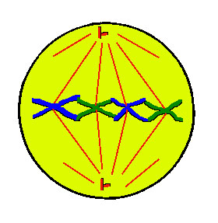
Brittany thinks this cell in in prophase but Nikki claims it is in metaphase. Who is correct and how do you know? (4 pts)
- Identify the phase during which the following things happen (8 pts):
Centromeres divide ______________________
Nuclear envelope dissolves _____________________
Chromosomes line up across the middle of the cell ________________________
Spindle fibers form _____________________________
Nuclear envelope reforms ______________________________
Chromatids split apart _______________________________
Spindle fibers attach _________________________________
DNA condenses into visible chromosomes ____________________________
- Why are there zero chromatids during anaphase and telophase? (2 pts)
- Would mitosis work without the spindle fibers? Why or why not? (3 pts)

