Name: ______Answer_Key______________________________________ Pd: ______
Homeostasis Homework—10 points

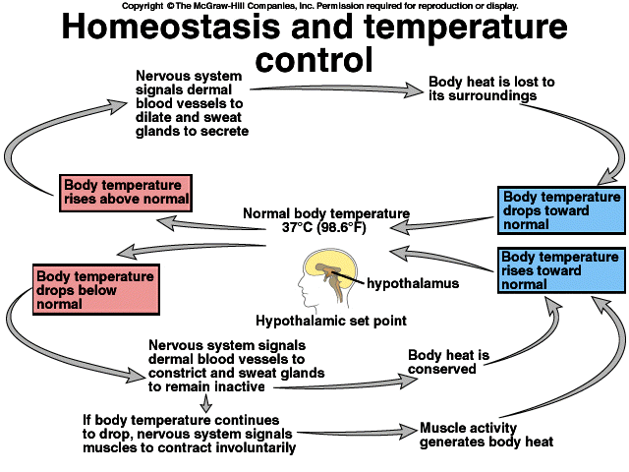
This diagram illustrates the homeostatic regulation of temperature control inside the body. The hypothalamus is a part of the brain that links the nervous system to the endocrine system. It is a monitoring center; it receives information about body temperature from the rest of the body and responds to those signals. The “hypothalamic set point” is 98.6°F—normal body temperature.
Other vocabulary in this diagram:
Dermal blood vessels: blood vessels in the skin
Secrete: In this context, to produce sweat. In a broader sense, secrete means to discharge or release a hormone or some other chemical from a cell or gland to the rest of the body.
Dilate: Increase in volume
Constrict: Decrease in volume
Questions to Answer: Use complete sentences.
- What is the stimulus for sweating? (1 pt)
The stimulus for sweating is high body temperature.
- How is the production of sweat an example of negative feedback? (2 pts)
In a negative feedback system, the response has the overall effect of reducing the stimulus. Sweat is a response to increased body temperature. Because sweat reduces the body temperature, this is a negative feedback system.
- What is the stimulus for constricting the dermal blood vessels? (1 pt)
The stimulus for constricting the dermal blood vessels is low body temperature.
- How is shivering—involuntary muscle contractions—an example of negative feedback? (2 pts)
Shivering is an example of negative feedback because the response—shivering—opposes the stimulus, which is low body temperature. After shivering, body temperature increases, so the original stimulus of “low body temperature” has been negated.
- Why are the negative feedback systems we’ve examined—insulin/glucagon, PTH/calcitonin, and this body temperature example—critical for maintaining homeostasis? (4 pts)
Negative feedback systems are critical for homeostasis because they ensure that conditions inside the body do not become extreme. In a negative feedback system, if some value in the body is too high, then the response will decrease that value. Conversely, if a value is too low, then a negative feedback system will result in that value being increased. The overall effect of these negative feedback systems is that conditions in the body fluctuate within a set, controlled range.

