Name: _________________________________________________________________________ Pd: ______
Homeostasis Homework—10 points

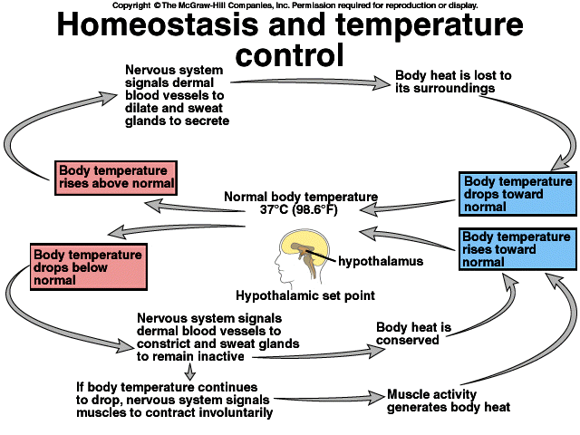
This diagram illustrates the homeostatic regulation of temperature control inside the body. The hypothalamus is a part of the brain that links the nervous system to the endocrine system. It is a monitoring center; it receives information about body temperature from the rest of the body and responds to those signals. The “hypothalamic set point” is 98.6°F—normal body temperature.
Other vocabulary in this diagram:
Dermal blood vessels: blood vessels in the skin
Secrete: In this context, to produce sweat. In a broader sense, secrete means to discharge or release a hormone or some other chemical from a cell or gland to the rest of the body.
Dilate: Increase in volume
Constrict: Decrease in volume
Questions to Answer: Use complete sentences.
- What is the stimulus for sweating? (1 pt)
- How is the production of sweat an example of negative feedback? (2 pts)
- What is the stimulus for constricting the dermal blood vessels? (1 pt)
- How is shivering—involuntary muscle contractions—an example of negative feedback? (2 pts)
- Why are the negative feedback systems we’ve examined—insulin/glucagon, PTH/calcitonin, and this body temperature example—critical for maintaining homeostasis? (4 pts)

