Name: _______________________________________________________________________________________ Pd: ______

Hemophilia: The “Royal” Disease

Hemophilia is an X-linked recessive disorder characterized by the inability to properly form blood clots. Until recently, hemophilia was untreatable, and only a few hemophiliacs survived to reproductive age because any small cut or internal hemorrhaging after even a minor bruise were fatal. Now hemophilia is treated with blood transfusions and infusions of a blood derived substance known as anti-hemophilic factor. However, such treatment is very expensive and involves the risk of contracting AIDS.

Hemophilia affects males much more frequently (1 in 10,000) than females (1 in 100,000,000). This occurs because a critical blood clotting gene is carried on the X chromosome. Since males only carry one X chromosome, if that is defective, hemophilia will immediately show up. An early death is likely. Females, on the other hand, carry two X chromosomes. If only one is defective, the other normal X chromosome can compensate. The woman will have normal blood clotting; she will simply be a carri er of the recessive defective gene. This fact will be discovered if some of her children are hemophiliacs. Naturally, women hemophiliacs are rare because it takes two defective X chromosomes in order for the condition to be seen.

Hemophilia has played an important role in Europe’s history, for it suddenly cropped up in the children of Great Britain’s Queen Victoria. It became known as the “Royal disease” because it spread to the royal families of Europe through Victoria’s descendants. Hemophilia first appeared in Victoria’s family in her eighth child, Prince Leopold, Duke of Albany. Throughout his short life, Leopold had suffered severe hemorrhages, and always was described as “very delicate.” Leading the life of a normal youngster was impossible for Leopold because any cut or bump could lead to death and it was necessary to keep him always under strict surveillance. However, in spite of all the protection, Prince Leopold died at the age of thirty-one as the result of a minor fall.

The appearance of hemophilia in one of Victoria’s sons upset and confused the Queen, who could only protest that the disease did not originate in her side of the family. Yet, a whisper about the “curse of the Coburgs” was spread about. This curse was supposed to have dated from the early nineteenth century, when a Coburg prince had married a Hungarian princess named Antoinette de Kohary. A monk, a member of the Kohary family, envied the wealth inherited by the happy couple from the bride’s father, and cursed future generations of Coburgs with the disease. Of course, hemophilia affecting Victoria’s offspring had nothing to do with the curse. The traditional view is that there was a mutation in either her egg or in a sperm of her father, Edward Augustus, Duke of Kent. From there it spread through the Royal Houses of Europe as monarchs arranged marriages to consolidate political alliances. We can trace the appearance of hemophilia as it popped up in Spain, Russia, and Prussia by looking at the family tree (see large chart at end of case).

- First, let’s take a look at Queen Victoria’s son Leopold’s family. His daughter, Alice of Athlone, had one hemophilic son (Rupert) and two other children—a boy and a girl—whose status is unknown.
a) What is the probability that her other son was hemophilic?
b) What is the probability that her daughter was a carrier? Hemophilic?
c) What is the probability that both children were normal—neither carriers nor hemophilic?
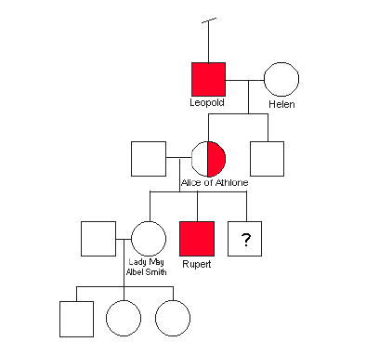
- Now for the Spanish connection: Victoria’s youngest child, Beatrice, gave birth to one daughter, one normal son, and two hemophilic sons. This pedigree is on the next page.
a) Using the pedigree of the Spanish royal family, find these genotypes:
Beatrice________ Henry_________ Eugenie_______ Leopold________
Maurice_______ Alfonso XIII __________ Alfonso __________ Gonzalo _________
b) The current King of Spain, Juan Carlos, is descended from Beatrice and Henry but does not have hemophilia. Could he be a carrier of hemophilia? Explain your answer.
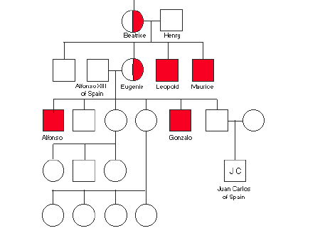
- Queen Victoria’s third child, Alice, married into the German royal family. Alice was a carrier of hemophilia. Her husband, Louis of Hesse, did not have hemophilia.
a) What are the genotypes of Alice and Louis?
b)What is the probability that Alice and Louis would have a son with hemophilia?
b)What is the probability that Alice and Louis would have a daughter with hemophilia?
- Of Alice’s six children, one suffered from hemophilia and two were carriers. At the age of three, her son Frederick bled for three agonizing days from a cut on the ear. Eventually, the flow of blood was stanched. But a few months later, while playing boisterously in his mother’s room, the boy charged headlong through an open window and fell to the terrace below. By the evening he was dead from the internal bleeding. Alice’s daughter Irene, a carrier, married her first cousin, Prince Henry of Prussia, and gave birth to two hemophilic sons.
- Given that Irene was a carrier and Prince Henry did not have hemophilia, what was the probability that this couple would have two hemophilic sons?

- Alice’s other daughter, Alix, was also a carrier. Alexandra (Alix) married Tsar Nikolas II and carried the disease into the Russian imperial family. She had four daughters, Olga, Tatiana, Marie, and Anastasia, before giving birth to the long-awaited son, Alexis, heir to the Russian throne. These children, along with their parents, were eventually murdered during the Russian Revolution.
a) Given that Alix is a carrier and Tsar Nikolas II did not have hemophilia, what is the probability that their daughter Anastasia was a carrier of hemophilia?
- Within a few months of his birth, his parents realized that their precious and only son, Alexis, had hemophilia. The first sign had been some unexpected bleeding from the navel, which had stopped after a few days. Much more serious, however, were the dark swellings that appeared each time the child bumped an arm or a leg. And worst of all was the bleeding into the joints. Neither well-experienced doctors nor numerous prayers to God by desperate parents seemed to help the suffering child. Distressed over their son’s condition, his parents, the Tsar and Tsarina, turned to the monk Rasputin, a spiritualist who claimed he could help Alexis. Rasputin received an unlimited trust from Alexandra because he was the only person who was able to relieve her son’s sufferings. How he managed to do this is uncertain. “A likely explanation is that Rasputin, with his hypnotic eyes and his self-confident presence, was able to create the aura of tranquility necessary to slow the flow of blood through the boys veins. Where the demented mother and the dithering doctors merely increased the tenseness of the atmosphere around the suffering child, Rasputin calmed him and sent him to sleep.” While Tsar and Tsarina were preoccupied with the health of their son, the affairs of state deteriorated, culminating in the Russian revolution. Alexis did not die from hemophilia. At the age of fourteen he was executed with the rest of the family.
- Supposing Alexis had lived and married a woman who was not a carrier and did not have hemophilia, what are the chances that his daughter would be a hemophiliac?
b) What are the chances his daughter would be a carrier?
d) What are the chances that his son would be a hemophiliac?
- Interestingly, neither of Queen Victoria’s parents had hemophilia. In fact, extensive research into the lineage of the British monarchy has uncovered no evidence at all of hemophilia for at least 17 generations before Queen Victoria. For this reason, some scholars have claimed that Victoria was an illegitimate child. Is there enough evidence to support this claim? Write a paragraph either in support of or in refutation of this claim.

