Energy and Enzymes Review Guide

You need to be confident with the following vocabulary. Visit http://quizlet.com/7434986/bio-gt-energy-and-enzymes-flash-cards/ for online vocab practice:

Energy Autotrophs
Heterotrophs Decomposers
Chemical energy Free energy
Entropy Second Law of Thermodynamics
calorie Activation energy
Biosynthesis Decomposition
Enzyme Substrate
Active site Induced fit
Enzyme-substrate complex Product (in the context of enzymatic reactions)

You should be able to…
- Explain how energy flows through an ecosystem
  - This includes describing the relationship between autotrophs and heterotrophs
- Differentiate between chemical energy and free energy
- Recognize which types of biological reactions require energy and which types of reactions release energy
- Recognize reactions that result in increased entropy and reactions that result in decreased entropy
- Explain why organisms, in spite of their organized structure, do not violate the 2nd Law of Thermodynamics
- Understand how the calorimetry lab we performed in class allowed us to collect data on the energy content of food
- Solve a calorie math problem
- Read and label an activation energy diagram—do you understand this?
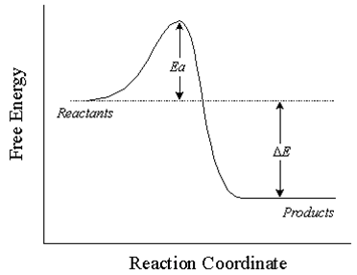
- Describe what happens during an enzyme-catalyzed reaction

As always, e-mail me with any questions or concerns you have about this material. Make time to come see me before or after school if you need additional help.

