Name: ______________________________________________________________________ Pd: _______

DNA Practice

- In the beginning of this unit, we discussed stability, variability, and fidelity. Using what you know about DNA, explain how DNA exhibits these characteristics.

- Sketch a generic nucleotide and label the sugar, the phosphate, and the nitrogen base. You may use simple shapes to represent the different parts of the nucleotide; you don’t need a detailed molecular structure.
- Sketch a DNA molecule that is three base pairs in length. You may use simple shapes to represent the different molecules involved; you do not need detailed molecular structures. Label adenine, thymine, guanine, cytosine, deoxyribose, and phosphate.
- Below is the sequence of one strand of DNA. Write the sequence for the complementary strand:
A T G C G T T T G G C A A C G T A C
- DNA replication occurs in the nucleus of the cell and can be divided into three phases:
1. Enzymes bind to DNA
2. The enzyme helicase “pulls apart” the two strands of the double helix
3. The enzyme DNA polymerase synthesizes new DNA strands using the two parent strands as templates
Given this information, and your modeling experience, why do you think DNA replication is described as “semi-conservative?”
- Explain how the base pairing rules make replication possible.
- Why is DNA replication necessary?
Use this karyotype to answer 8-10.
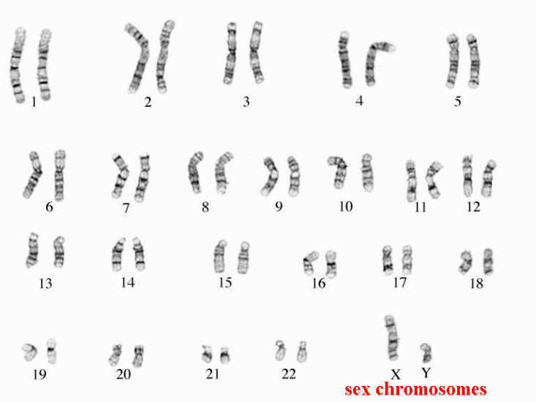
- Is this karyotype from a gamete or from a somatic (non-sex) cell? How can you tell?
- Does this individual have male or female sex chromosomes?
- Which pair of chromosomes in this karyotype is not homologous?
- Using the terms gamete (or egg and sperm), haploid, diploid, and fertilization, explain how a human ends up inheriting DNA from each parent.

