Classic DNA Experiments
This will not be graded. However, you are responsible for this testable information.
Oswald Avery
Avery was an American biologist working in the 1940s. Like Griffith, Avery worked with bacteria. In an effort to refine Griffith’s original experiment, Avery replicated the experiment with some important modifications. Read over Avery’s procedure below:
- Inoculate one group of mice with live R strain.
- Inoculate one group of mice with live S strain.
- Inoculate one group of mice with heat-killed S strain.
- Inoculate one group of mice with both live R strain and heat-killed S strain.
- Denature all of the protein in a culture of S strain bacteria. Combine these “protein-less” S strain with live R strain and inject into a group of mice.
Avery’s results were intriguing. For the first four treatment groups, his results were the same as Griffith’s, as expected. In the fifth treatment group, the mice also ended up dead.
- Fill in the table below with the set-up and results of Avery’s experiments. The first one has been done for you as an example. (Hint: You may need to refer to your class notes on Griffith in order to complete the table.)
Treatment | Observations
Live R strain | Living mice

Answer the following questions about Avery’s experiment:
- How did Avery modify Griffith’s experimental set-up? Be specific.
__________________________________________________________________________________________________________________________________________________________________________________________________________________________________________________________________________________________________________________________
- Based on Avery’s results, what could the scientific community conclude about the nature of the transforming principle first observed by Griffith? Why?
___________________________________________________________________________________________________________________________________________________________________________________________________________________________________________________________________________________________________________________________
Alfred Hershey and Martha Chase
Hershey and Chase studied viruses in the 1950s. Their research focused on a specific group of viruses known as bacteriophages. Bacteriophages are viruses that specifically infect bacterial cells. When Hershey and Chase were working, it was well known that bacteriophages were made of two kinds of macromolecule: DNA and protein. Examine the following diagrams of bacteriophages. The one on the left is a cartoon; the one on the right is an actual electron micrograph:

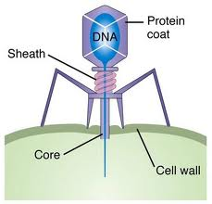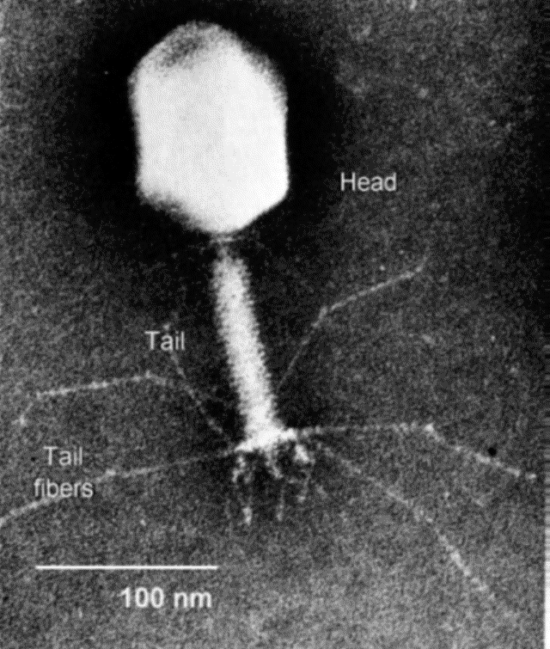
Avery had already published his work, but the debate over what molecule was responsible for carrying genetic information still raged. Using the bacteriophages they knew so well, Hershey and Chase designed an elegant, straightforward experiment to settle the debate over the nature of the genetic material. When bacteriophages infect cells, the cell becomes “hijacked.” The infected cells will begin churning out copies of the virus. This phenomenon was very much like the transforming principle observed and described by Griffith. Whatever was happening between the bacteriophages and the infected cells almost certainly involved a transfer of genetic information.

Hershey and Chase used fluorescent molecules to “tag” different parts of the virus. These fluorescent markers could be (relatively) easily detected and traced throughout the course of an experiment, and they allowed researchers to precisely track the fates of different molecules. (Fluorescent tagging is still an important research tool in biology.) In one experimental group, the researchers attached fluorescent tags to protein molecules in the bacteriophage. In another experimental group, the researchers attached fluorescent tags to the bacteriophages’ DNA. They then allowed each experimental group to infect a culture of E. coli. After incubating the experimental bacteriophages with the E. coli cultures, Hershey and Chase looked for any new viruses that were produced by the infection and characterized them Here is what they found:
Treatment | Was the infection successful? | Observations
Bacteriophage protein tagged with radioactive sulfur | Yes; new viruses were produced by the infected E. coli | No radioactivity observed in new viruses  No radioactivity observed inside of infected E. coli cells
Bacteriophage DNA tagged with radioactive phosphorous | Yes; new viruses were produced by the infected E. coli | Radioactivity was observed in new viruses  Radioactivity detected inside of infected E. coli cells

Answer the following questions about Hershey-Chase:
- What could Hershey and Chase conclude from their experiment? Be specific and support your conclusion with evidence.
_____________________________________________________________________________________________________________________________________________________________________________________________________________________________________________________________________________________________________________________________________________________________________________________________________________________________________________________________________________________________________________________________________________
- Why were bacteriophages so well-suited for investigating the question of whether DNA or protein was the genetic material?
____________________________________________________________________________________________________________________________________________________________________________________________________________________________________________________________________________________________________________________________________________________________________________________________________________________________________
- How come Hershey and Chase used sulfur in the protein tags but used phosphorous in the DNA tags?
_________________________________________________________________________________________________________________________________________________________________________________________________________________

Erwin Chargaff
After Hershey and Chase finally settled the debate in favor of DNA, biologists began to devote their time to learning more about DNA. It had been well known for a long time that DNA was composed of carbon, hydrogen, oxygen, nitrogen, and phosphorous. It was also well known that there were four specific nitrogen bases—large rings of carbon and nitrogen—found in DNA: adenine (A), guanine (G), cytosine (C), and thymine (T). But the arrangement was not known. Below are diagrams of the four different nitrogen bases found in DNA:
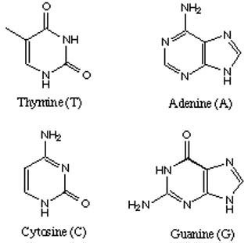
(Recall that a nucleotide contains a phosphorous group, a sugar, and a nitrogen base. The diagrams here are not nucleotides; they are nitrogen bases.)
Chargaff analyzed the chemical composition of a wide array of different DNA samples. And he found an intriguing pattern. In each sample of DNA he tested, the percentage of adenine in the sample was equal to the percentage of thymine in the sample. Furthermore, the percentage of cytosine in a sample was always equal to the percentage of guanine in a sample. For example, his analysis of human DNA found that:
%A = 30.9% %C = 19.8%
%G = 19.9% %T = 29.4%
From this, Chargaff concluded that these nitrogen bases must exist in pairs, and he devised base-pairing rules. Write the DNA base pairing rules in the space below.

Rosalind Franklin, Maurice Wilkins, Francis Crick, and James Watson
Once the base-pairing rules had been established by Chargaff, the race was on to uncover the specifics of DNA structure. Biologists in the 1950s knew that accurately describing DNA structure would be considered one of the crowning achievements in 20th century biology (they were right).
Around this time, a technology called x-ray crystallography was coming into widespread use for studying molecular structure. Proteins could be crystallized, and once crystallized, subjected to a barrage of X-rays. These X-rays would “bounce” off the protein crystal and form characteristic patterns. Talented scientists could accurately interpret these X-ray patterns in order to come up with a 3D structure for the protein.

In Cambridge, England, a young female scientist named Rosalind Franklin was working on X-ray crystallography in the lab of Maurice Wilkins. They were concentrating their efforts on making DNA crystals and obtaining reliable crystallography results. At that point in time, X-ray crystallography appeared to be the most likely way to gain information about DNA structure. Franklin was an expert in crystallography and meticulous in her procedures and analysis; her work had a reputation for reliability and quality.

In a neighboring lab, Francis Crick and James Watson were also working on DNA. Their work was primarily done through model building—trial and error using data published by other labs. However, it became increasingly clear that the most accurate and recent information available was to be found in the X-ray pictures of Wilkins and Franklin. Without consulting Franklin, Wilkins made the X-ray data available to Watson and Crick. Shortly thereafter, Watson and Crick constructed their famous double helix model of DNA. Watson, Crick, and Wilkins were all awarded the Nobel Prize. Rosalind Franklin died before the prize was awarded. Her death was attributed to her lengthy, frequent exposure to X-rays. The Nobel Prize is never awarded posthumously, and thus Franklin’s contributions are rarely recognized alongside the work of Watson and Crick.

