Name: ___________________________________________________ Pd:______
Diploid and Haploid Cells
Most human cells contain 46 chromosomes. These chromosomes exist in pairs—the following karyotype shows you this clearly:
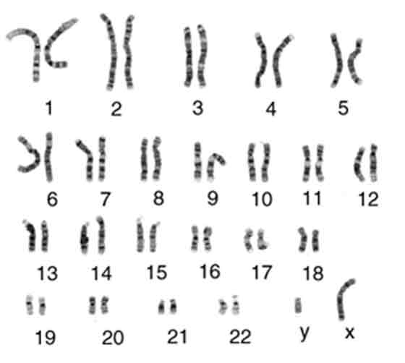
Notice that there are two copies of chromosome 1, two copies of chromosome 2, etc. Everyone has 2 copies of each chromosome in their body cells. These cells are described as diploid cells. The two copies together make a homologous pair. Each chromosome of the pair contains the same genes. For example, chromosome 7 contains the cystic fibrosis gene. Both copies of chromosome 7 have this gene! However, each copy may have a slightly different version of the gene. One chromosome 7 might have a healthy version of the CF gene while the other chromosome 7 might have a mutated version of the CF gene. Or they could both be healthy, or even both mutated. The point is that most of your cells have two copies of every chromosome and therefore two copies of every gene on those chromosomes.
Questions to Answer
- Why do you have 2 copies of every chromosome? Where does each copy come from?
- What is a diploid cell?

- How many chromosomes are in a human diploid cell?
- Do the chromosomes within a pair have identical genetic information?

However, sex cells—eggs and sperm, also called gametes—only have 23 chromosomes. They only have one copy of each chromosome, as shown in the following karyotype:
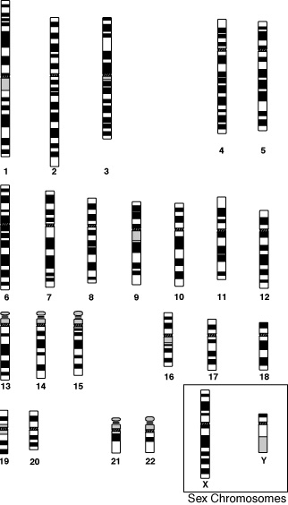
This cell—an egg or sperm cell—has only one of each chromosome. As a result, it is described as a haploid cell. There are no homologous pairs here, because there is only one copy of each chromosome. During fertilization, this cell would combine with another haploid cell to form a single diploid cell. The 23 chromosomes of this gamete would pair up with the 23 chromosomes of another gamete to result in a single cell that had homologous pairs of every chromosome.
Questions to Answer:
- What does haploid mean?
- How many chromosomes are in a human haploid cell?
- Why are human gametes haploid?

